Day #10 - How do I start?

Welcome Back!

Hope I didn’t lose you yesterday. I know it is a lot to take in but I believe in you.

I know you may be asking, “ But how and where do I start?”

Well, today you are in for a treat. Today I will give you five (5) easy steps to get this show on the road.

Ready… Set… Click below lets GO!

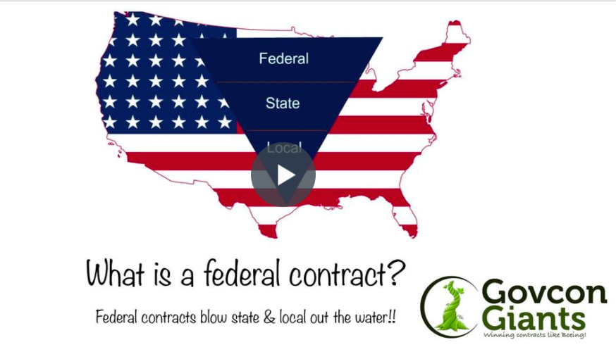

For today’s homework you will have to put on your creative cap because we are going to start exploring names for your new business.

Head over to the 5 Step Formula Now

Big hug,

Eric Coffie

